Game Design Document (GDD)











***‘Oh Boid’*** – Y.U.G.E.

Contents

|  |  |  |
| --- | --- | --- |
| Table of Contents  [1 Game Overview](https://n-xovwktmtjsnaxyc2mwes2xu7pohqedmdm6zjw5q-2lu-script.googleusercontent.com/userCodeAppPanel)  [2 High Concept](https://n-xovwktmtjsnaxyc2mwes2xu7pohqedmdm6zjw5q-2lu-script.googleusercontent.com/userCodeAppPanel)  [3 Synopsis](https://n-xovwktmtjsnaxyc2mwes2xu7pohqedmdm6zjw5q-2lu-script.googleusercontent.com/userCodeAppPanel)  [4 Game Objectives](https://n-xovwktmtjsnaxyc2mwes2xu7pohqedmdm6zjw5q-2lu-script.googleusercontent.com/userCodeAppPanel)  [5 Game Rules](https://n-xovwktmtjsnaxyc2mwes2xu7pohqedmdm6zjw5q-2lu-script.googleusercontent.com/userCodeAppPanel)  [6 Game Play](https://n-xovwktmtjsnaxyc2mwes2xu7pohqedmdm6zjw5q-2lu-script.googleusercontent.com/userCodeAppPanel)  [6.1 Game Controls](https://n-xovwktmtjsnaxyc2mwes2xu7pohqedmdm6zjw5q-2lu-script.googleusercontent.com/userCodeAppPanel)  [6.2 Maps](https://n-xovwktmtjsnaxyc2mwes2xu7pohqedmdm6zjw5q-2lu-script.googleusercontent.com/userCodeAppPanel)  [7 Players](https://n-xovwktmtjsnaxyc2mwes2xu7pohqedmdm6zjw5q-2lu-script.googleusercontent.com/userCodeAppPanel)  [7.1 Characters](https://n-xovwktmtjsnaxyc2mwes2xu7pohqedmdm6zjw5q-2lu-script.googleusercontent.com/userCodeAppPanel)  [7.2 Metrics](https://n-xovwktmtjsnaxyc2mwes2xu7pohqedmdm6zjw5q-2lu-script.googleusercontent.com/userCodeAppPanel)  [7.3 States](https://n-xovwktmtjsnaxyc2mwes2xu7pohqedmdm6zjw5q-2lu-script.googleusercontent.com/userCodeAppPanel)  [7.4 Weapons](https://n-xovwktmtjsnaxyc2mwes2xu7pohqedmdm6zjw5q-2lu-script.googleusercontent.com/userCodeAppPanel)  [8 NPC](https://n-xovwktmtjsnaxyc2mwes2xu7pohqedmdm6zjw5q-2lu-script.googleusercontent.com/userCodeAppPanel)  [8.1 Enemies](https://n-xovwktmtjsnaxyc2mwes2xu7pohqedmdm6zjw5q-2lu-script.googleusercontent.com/userCodeAppPanel)  [8.1.1 Enemy States](https://n-xovwktmtjsnaxyc2mwes2xu7pohqedmdm6zjw5q-2lu-script.googleusercontent.com/userCodeAppPanel)  [8.1.2 Enemy Spawn Points](https://n-xovwktmtjsnaxyc2mwes2xu7pohqedmdm6zjw5q-2lu-script.googleusercontent.com/userCodeAppPanel)  [8.2 Allies / Companions](https://n-xovwktmtjsnaxyc2mwes2xu7pohqedmdm6zjw5q-2lu-script.googleusercontent.com/userCodeAppPanel)  [8.2.1 Ally States](https://n-xovwktmtjsnaxyc2mwes2xu7pohqedmdm6zjw5q-2lu-script.googleusercontent.com/userCodeAppPanel)  [8.2.2 Ally Spawn Points](https://n-xovwktmtjsnaxyc2mwes2xu7pohqedmdm6zjw5q-2lu-script.googleusercontent.com/userCodeAppPanel)  [9 Art](https://n-xovwktmtjsnaxyc2mwes2xu7pohqedmdm6zjw5q-2lu-script.googleusercontent.com/userCodeAppPanel)  [9.1 Setting](https://n-xovwktmtjsnaxyc2mwes2xu7pohqedmdm6zjw5q-2lu-script.googleusercontent.com/userCodeAppPanel)  [9.2 Level Design](https://n-xovwktmtjsnaxyc2mwes2xu7pohqedmdm6zjw5q-2lu-script.googleusercontent.com/userCodeAppPanel)  [9.3 Audio](https://n-xovwktmtjsnaxyc2mwes2xu7pohqedmdm6zjw5q-2lu-script.googleusercontent.com/userCodeAppPanel)  9.4 What you Developed   |  | | --- | |  | | Game Development Team Members    PRODUCER  Alex Giang  Michael Yee  Shawn Chua  Tony La    PRODUCTION MANAGER  Michael Yee    PRODUCTION COORDINATOR  Alex Giang  Michael Yee  Shawn Chua  Tony La  GAME DESIGNERS  Alex Giang  Michael Yee  Shawn Chua  Tony La  SYSTEMS/IT COORDINATOR  Michael Yee  Tony La  PROGRAMMERS  Alex Giang  Michael Yee  Shawn Chua  Tony La  TECHNICAL ARTISTS  Shawn Chua  AUDIO ENGINEERS  Alex Giang  Tony La  UX TESTERS  Alex Giang  Michael Yee  Shawn Chua  Tony La |

|  |
| --- |
|  |

# 1 Game Overview

Title: The Legend of Xela: Boid of the Wild

Platform: PC Standalone

Genre: Action Adventure

Rating: (17+) ESRB

Target: Casual gamer (aging from 12 - 30)

Serious games

Release date: May, 2018

Publisher: YUGE Studios

Description: The Legend of Xela: Boid of the Wild is a 3D action adventure game inspired by various critically acclaimed games such as No Man’s Sky and Call of Duty: Ghosts. The player a gender-neutral character who appears in a mysterious and seemingly endless world with no recollection of how they got there. At the same time, evil monsters dwell within the depths of this world, aware of the player’s existence and will do what it takes to devour their being. Fortunately, the player is equipped with a pistol: a tool in which they’ll use to survive.

Genre:

The Legend of Xela: Boid of the Wild is an action adventure game, where there’s action in which the player must fight against various enemies with their pistol in hand and adventure in a seemingly endless world. The world consists of various obstacles for the player to travel through that affects their decision making in terms of fighting and movement.

# 2 High Concept

The Legend of Xela: Boid of the Wild sets the player in a procedurally-generated world, a huge grassy landmass. Monsters inhabit this same world and will do what it takes to destroy the main character.

# 3 Synopsis

You awaken in an unknown world with no recollection of how you got there. Monsters inhabit this seemingly endless world and will do whatever it takes to kill you. You are tasked with one objective: surviving.

# 4 Game Objectives

The objective of the game is to survive with your pistol with unlimited ammo supply while monsters are chasing you.

# 5 Game Rules

The game is designed to be an open world. It is mainly a large grass-field that the player can traverse around. There is little to interact with in the environment other than the enemies that will keep spawning and head towards you. The player has the full power to move as they please and fire their gun whenever although it affects only enemies. The enemies are designed to track the player’s location and head towards them with the goal of killing them.

# 6 Game Play

## 6.1 Game Controls (PC)

|  |  |
| --- | --- |
| W | Move Up |
| A | Move Left |
| S | Move Down |
| D | Move Right |
| Left-Shift | Hold to run |
| Esc | Pause Menu |
| Left Mouse Button | Fire Pistol |

### 6.2 Maps

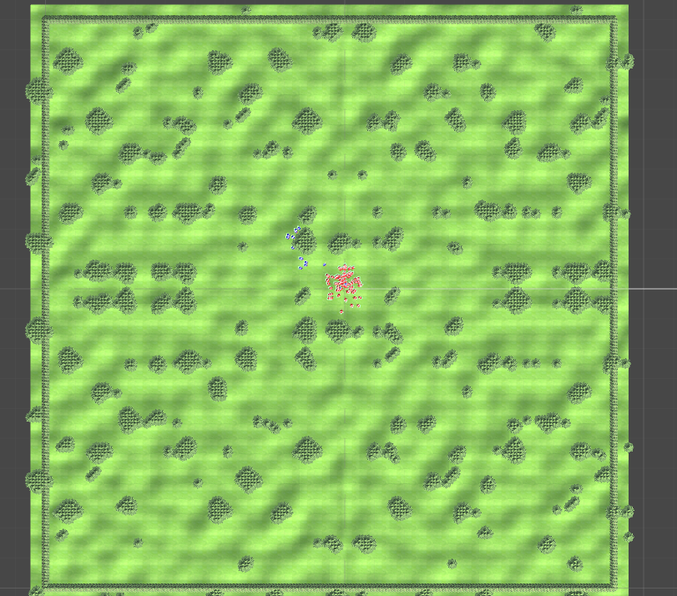

Example of the procedurally generated world.

# 7 Players

## 7.1 Characters

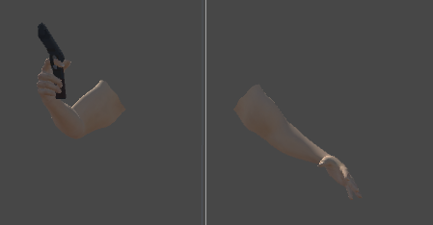

The character is an autonomous gun. Guns do kill after all.

## 7.2 Weapons



The Super Pistol – An Automatic Pistol that fires at 25 damage per second.

# 8 NPC (optional)

## 8.1 Enemies

Boids are the only enemies.

### 8.1.1 Enemy States

The Boids will either be traversing nodes that will lead them to the player’s location (via pathfinding algorithm), following the player (when the Boid gets close enough) or in a stunned state if they touch the player or get shot by the player.

### 8.1.2 Enemy Spawn Points

Randomized spawn points around the map that are 30 to 45 units away from the player. FlockControllers will respawn new Boids when there are no more Boids in their array (within their control).

# 9 Art *

## 9.1 Setting

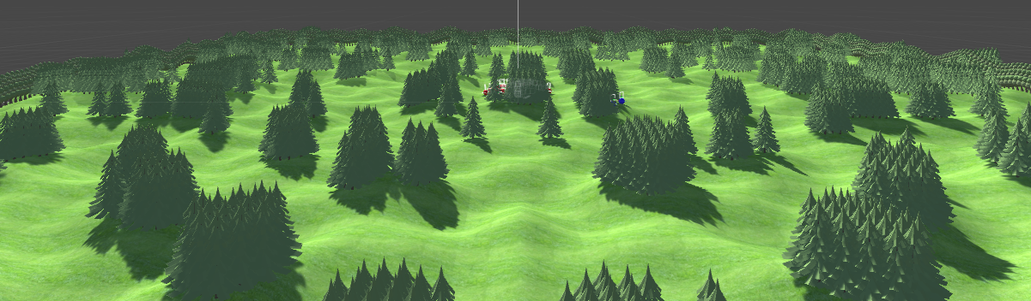

The game takes place in a procedurally-generated world where the land varies by the player’s current position. The above picture is an example of such a world. Various object will be scattered around this world serving as obstacles to the player. These obstacles will affect the player in their decision making when it comes to traversal and fighting.

## 9.2 Level Design



As stated before, the levels are endless. However due to limitations of the system, the map will be limited. Walls will prevent the player from exploring beyond the preset procedurally generated land. This is designed to give an open-world sort of feeling with endless gameplay as influence.

## 9.3 Audio

|  |  |  |
| --- | --- | --- |
| Name | Category | Description |
| Pistol.wave | SFX | The pistol shot sound |
| Rifle.wave | SFX | Rifle shot sound |
| Horror field.mp3 | BGM | Main Menu BGM |
| Suspense Loop.mp3 | BGM | End Credits BGM |
| BossMain.wav | BGM | Main Game Scene Theme |

9.4 What you Developed

Tony:

Logos









Shawn:

Arm Models with Gun

